WordSynk Migration Tool

Translation & Interpreting Account Migration

Tool Access:
- https://webapp-live-wordsynkmigration.azurewebsites.net/Home/Index
- Login in using the email and password provided (shared access)

Process:
- Create a .csv file
- In column A insert the account code (translation) or OG code (interpreting)
- In column B indicate whether the migration is “Translation” or “Interpreting” (ensure capital letter at start)
- Save .csv file somewhere accessible
- Click on “Configure Migration Job”

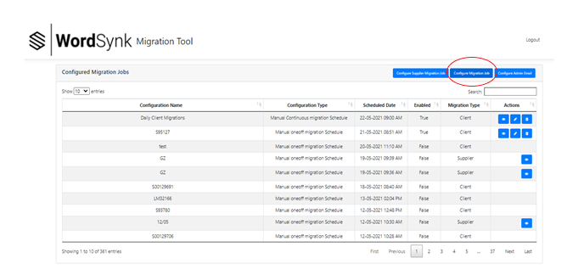
- In the pop up do the following:
  - Configuration name – choose a relevant name
  - Configuration type – choose “Manual Oneoff Migration schedule”
  - Schedule Date & Time – add date and time for migration
(N.B during BST you will need to enter a time 1 hour earlier than the current time to account for the difference)
  - Upload files – upload the csv file you have chosen

- Click “submit”

- On the main screen you will see you scheduled migration, with a “view”, “edit” and “delete” symbol next to it
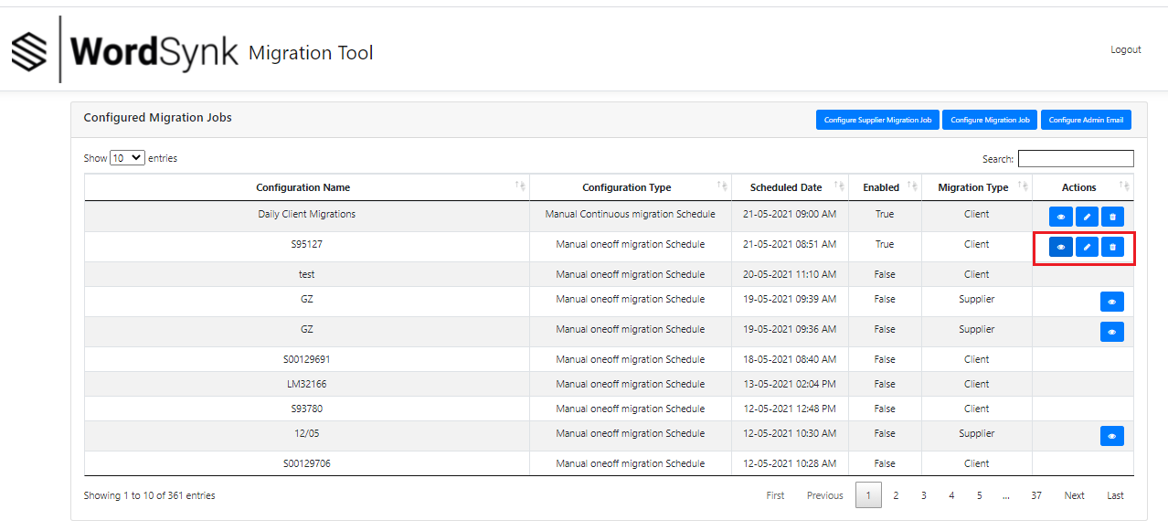
- To view which codes are included, click on the eye symbol (view), to change the date and time, click on the pencil (edit) and to delete the migration, click on the bin.

- Once the migration has successfully processed, these view/edit/delete symbols will disappear

- If the migration time has lapsed and the symbols have not disappeared, the migration has not taken place – you should click on the edit button and change the time until migration has successfully processed

- Once the new migration is complete, you should add the information to the “Migrated Accounts” list on teams
N.B. Contacts migrated are no longer tracked; if you are not sure if a contact has migrated you can do one of the following:
- Raise a PS ticket to check
- Re-migrate the account and review the report
- Clicking on “forgotten password?” and adding the email address – if the client has not been migrated you will get an error message of “Email does not exist”
(N.B. only do this if the client has not managed to access the site as it will prompt a password reset process)

Continuous Migration Schedule
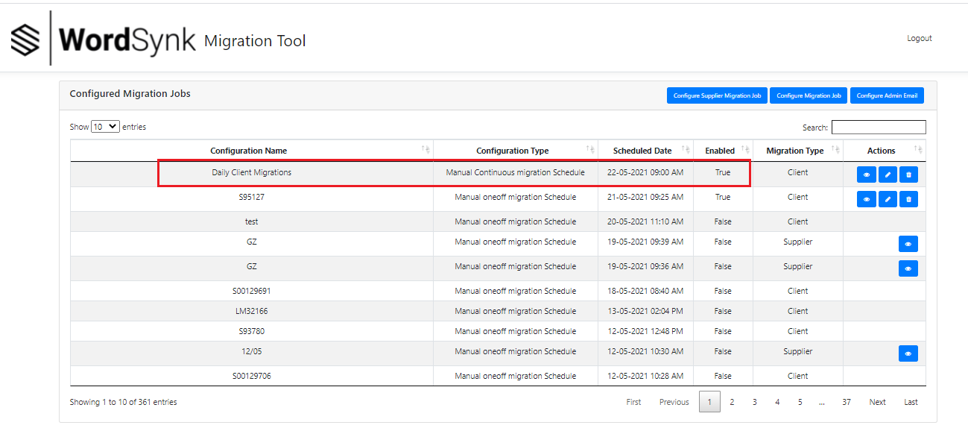
There is a daily migration which runs automatically to identify new contacts who have been set up or imported to TMS/IMSD on existing migrated accounts:
The migration runs automatically once a day at 10 am (during BST) and 9 am GMT
Any new accounts migrated need to be added to the schedule:
- Click on the view button next to the migration

- You will be shown a list of all accounts included in the daily migration

- To add new accounts, click on “Add TMS Codes” (translation) or “Add IMSD Codes” (interpreting)

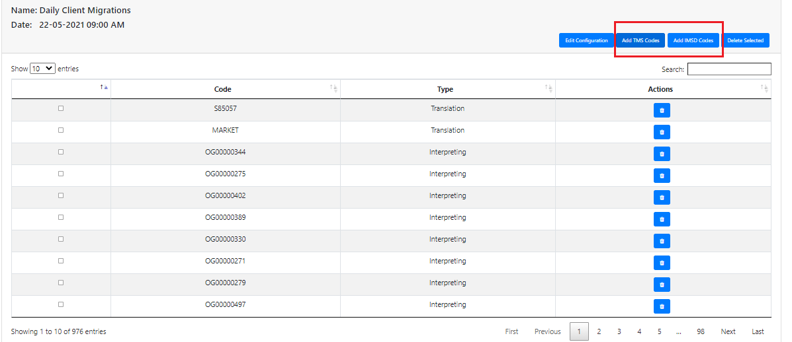

Migration Report
The migration report is set up to be delivered to wsmigration@thebigword.com – this is a shared inbox that users can get access to.
The report can also be configured to go to other email addresses by going to “Configure Admin Email”.
- Due to the volume of accounts and contacts, the migrations are now run in batches of 5000 and there will be an email and report for each batch
- The email gives a high level overview of migration success and failure
- The report gives a more detailed overview by contact:
SsoUserId | Email | Scode | Status | MigrationType | ErrorMessage | CreatedUTC
- SsoUserID – this is the SSO ID of the user, it usually sits in the background and is not used by Ops
- Email – email address of user
- Scode – Account or OG code
- Status – this will either be “Failure User”, “Duplicate User” or “Success User”
- MigrationType – either “Interpreting” or “Translation”
- ErrorMessage – this will be blank for successful migrations or will contain the reason for failure
- Created UTC – date/time of migration
Failure reasons:
- Invalid email – email address is technically invalid
- User exits in Migrated user table – contact has already been migrated
- Empty email – no email address against account
- Multiple logins for same billing account – more than one person is using the email address on the same account
Correction of the issue will mean that the migration will be picked up again in the next daily run.

Linguist Migration

Tool Access:
- https://webapp-live-wordsynkmigration.azurewebsites.net/Home/Index
- Login in using the email and password provided (shared access)

Process:
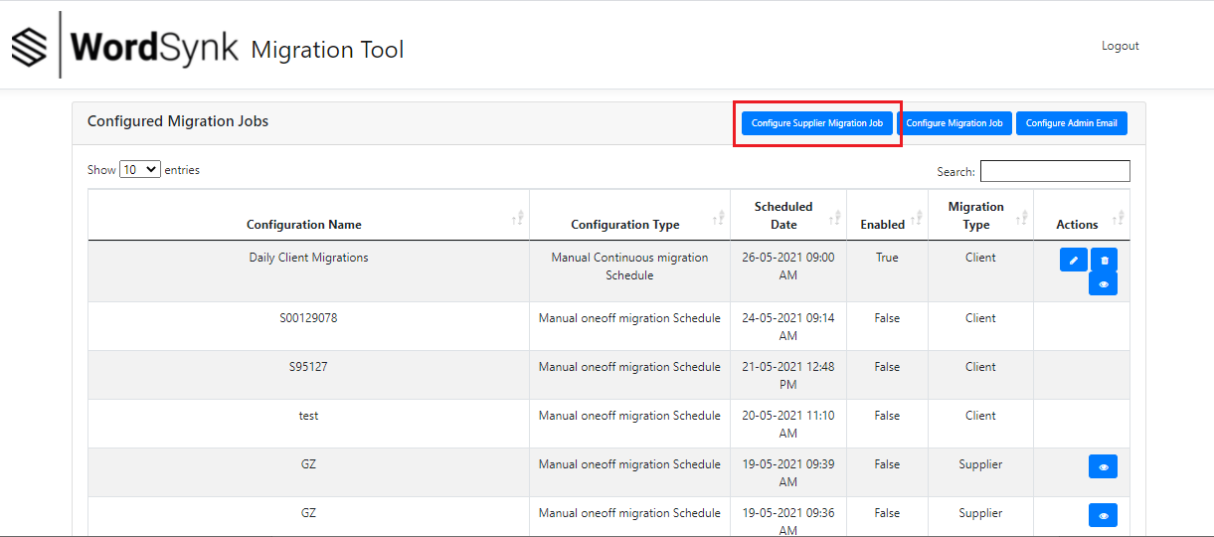
- Click on “Configure Supplier Migration Job”
- In the pop-up fill in the following:
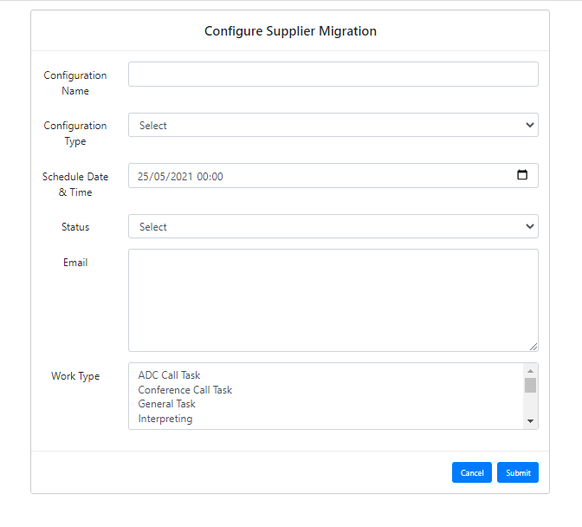
  - Configuration name – give the migration a name
  - Configuration type – choose “Manual One-Off Migration Schedule”
  - Schedule Date & Time – add date and time for migration
(N.B during BST you will need to enter a time 1 hour earlier than the current time to account for the difference)
  - Status – define the status of the linguist profiles migrating (this should be “authorised” as standard)
  - Email – list of email addresses for migration (separated by comma)
  - Worktype – this is a non-mandatory field which allows you to choose which type of tasks to migrate

- Click on “submit”

- On the main screen you will see you scheduled migration, with a “view”, “edit” and “delete” symbol next to it
- To view which codes are included, click on the eye symbol (view), to change the date and time, click on the pencil (edit) and to delete the migration, click on the bin.

- Once the migration has successfully processed, the edit/delete symbols will disappear – the view symbol will remain

- If the migration time has lapsed and the symbols have not disappeared, the migration has not taken place – you should click on the edit button and change the time until migration has successfully processed

- Once the new migration is complete, you should add the information to the “WSN Migrated Linguist” list on teams

Migration Report
The migration report is set up to be delivered to wsmigration@thebigword.com – this is a shared inbox that users can get access to.
The report can also be configured to go to other email addresses by going to “Configure Admin Email”.
- The email gives a high level overview of migration success and failure
- The report gives a more detailed overview by linguist:
SsoUserId | Email | Pcode | Status | MigrationType | ErrorMessage | CreatedUTC
- SsoUserID – this is the SSO ID of the user, it usually sits in the background and is not used by Ops/LR
- Email – email address of user
- pcode – PCode of the linguist
- Status – this will either be “Success User” or “Failure User”
- MigrationType – either “Interpreting Supplier” or “Translation Supplier”
- ErrorMessage – this will be “Success User” for successful migrations or will contain the reason for failure
- Created UTC – date/time of migration
Failure reasons:
- The migration tool is based on the email address and NOT the pcode.
- The tool will first look for linguists in IMSD & TMS, meeting the criteria you have added
- If found, it will then look for matching linguists in TLW, meeting the criteria you have added
Error Message | Meaning | Action required
Sso Id of Supplier is already mapped in Gts Sso Legacy Users | The user has already migrated | n/a
Supplier with this profile is already exist in Profile Manager ProfileId : XXXXXX | A separate profile for the user has already been created in WSN | Raise a PS ticket and ask them to map the SSO ID of the linguist to allow the systems to match
Supplier not found in both TMS and IMSD | User does not exist as authorised in either TMS or IMSD | Review profiles and ensure they are marked as authorised, with valid email addresses
Supplier not found in both TLW and IMSD/TMS to migrate | User found in TMS/IMSD but does not exist in TLW as authorised | Review profiles and ensure that they are authorised in all systems and that email addresses match
Correction of the issue will mean that the migration will complete if run again.

